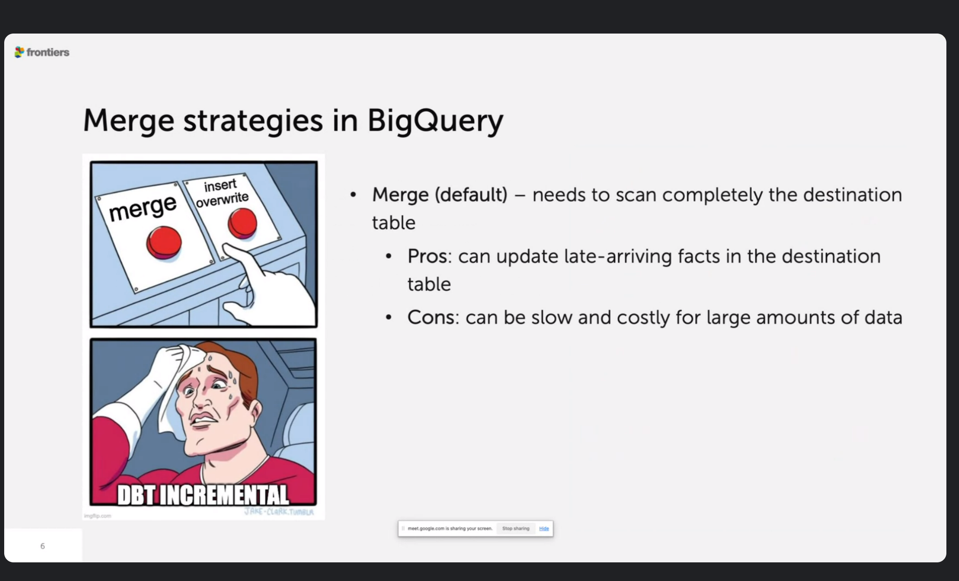

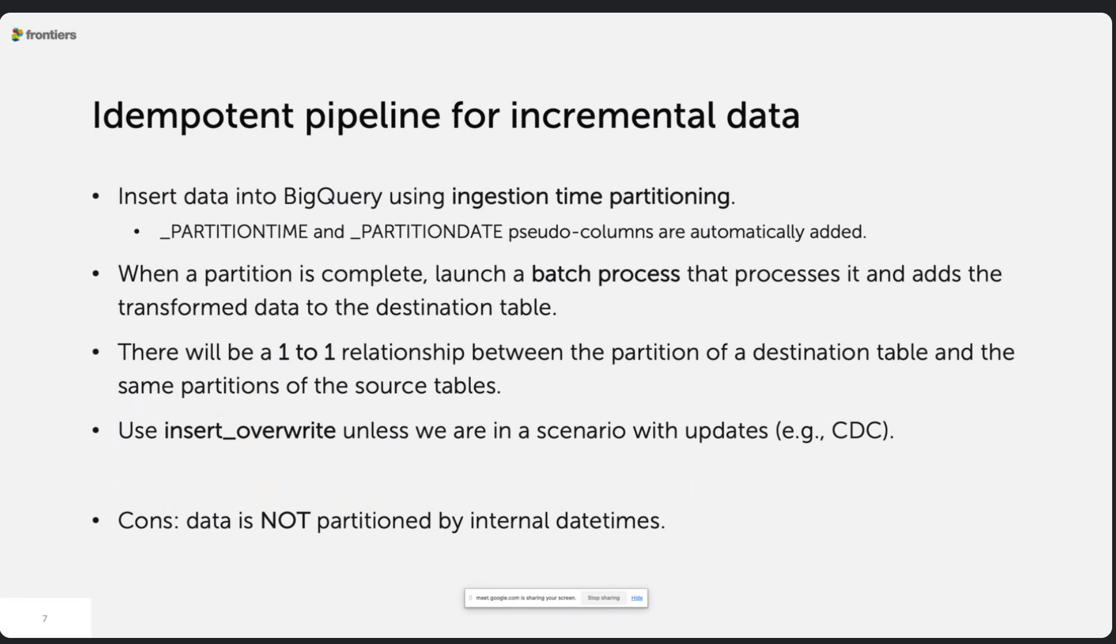

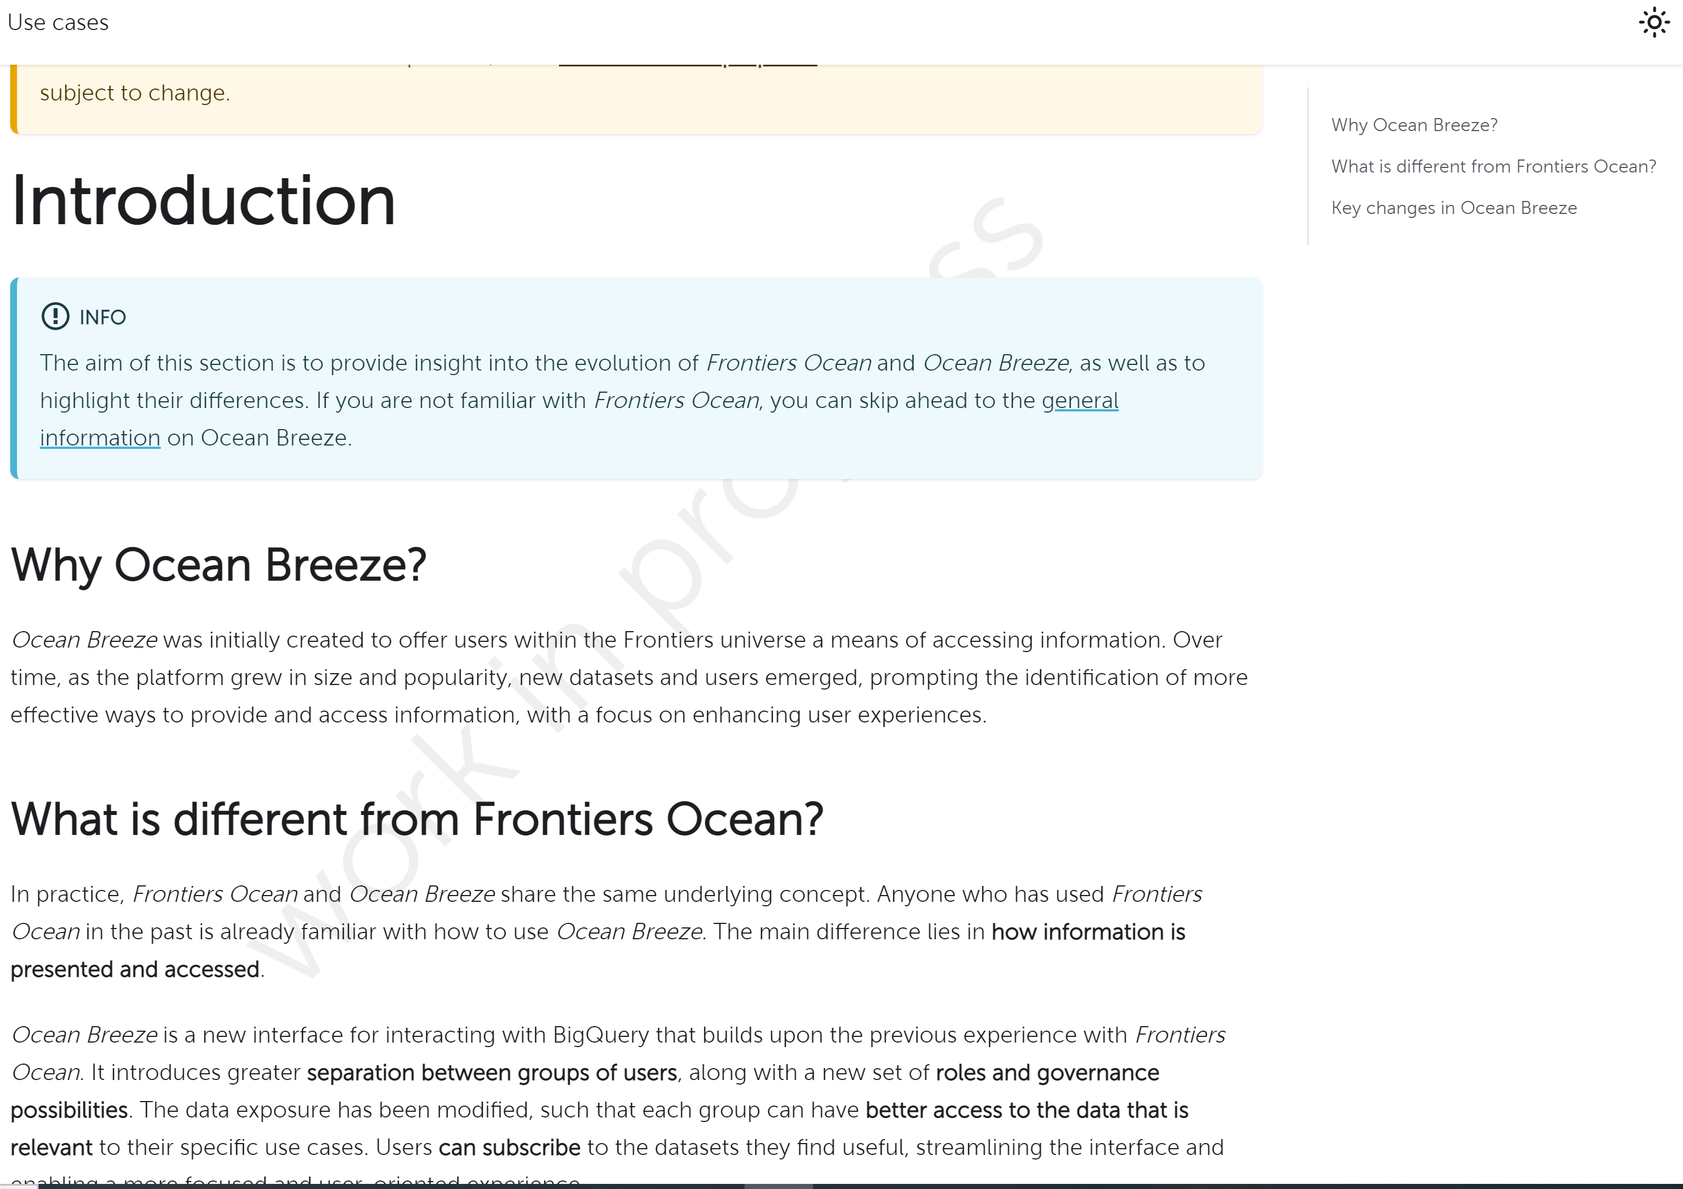

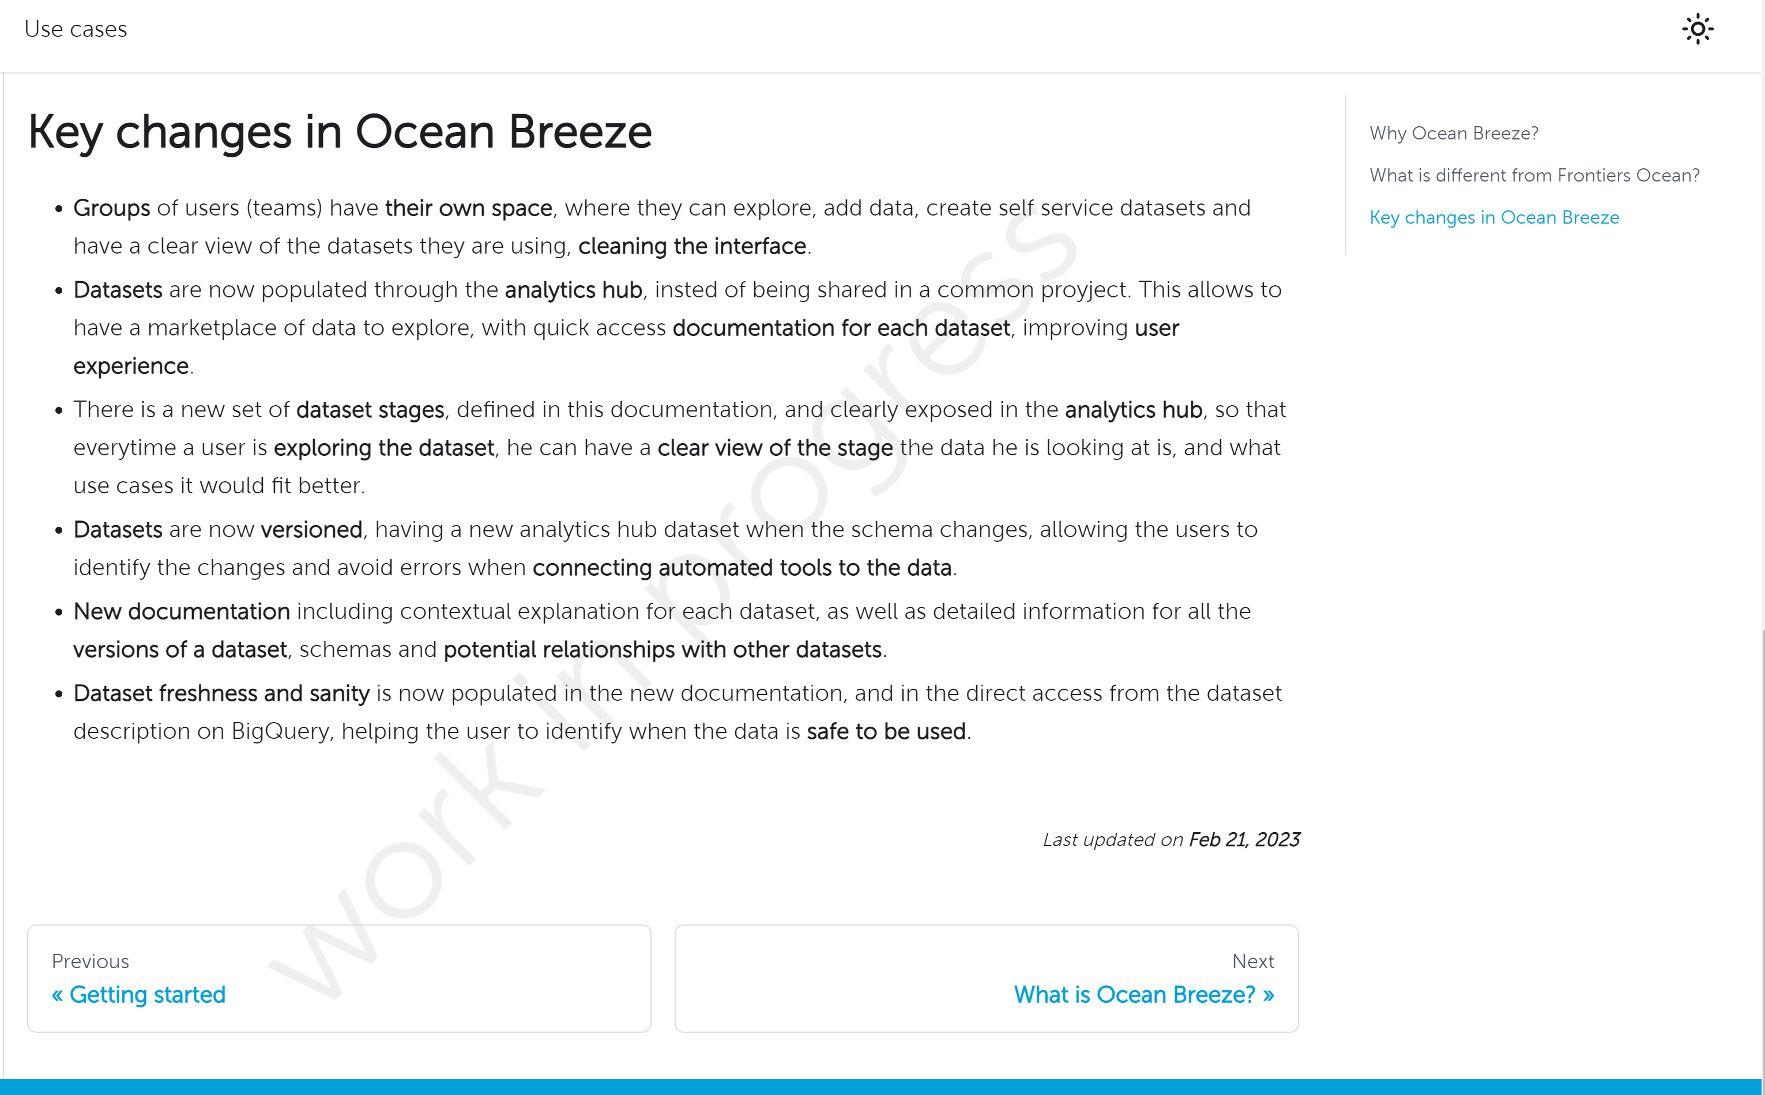

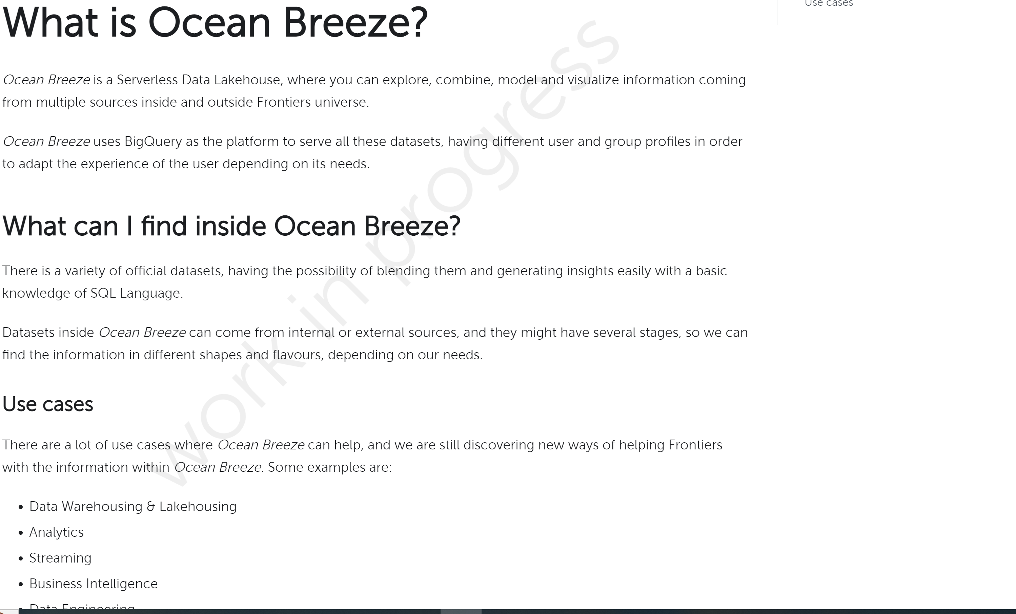

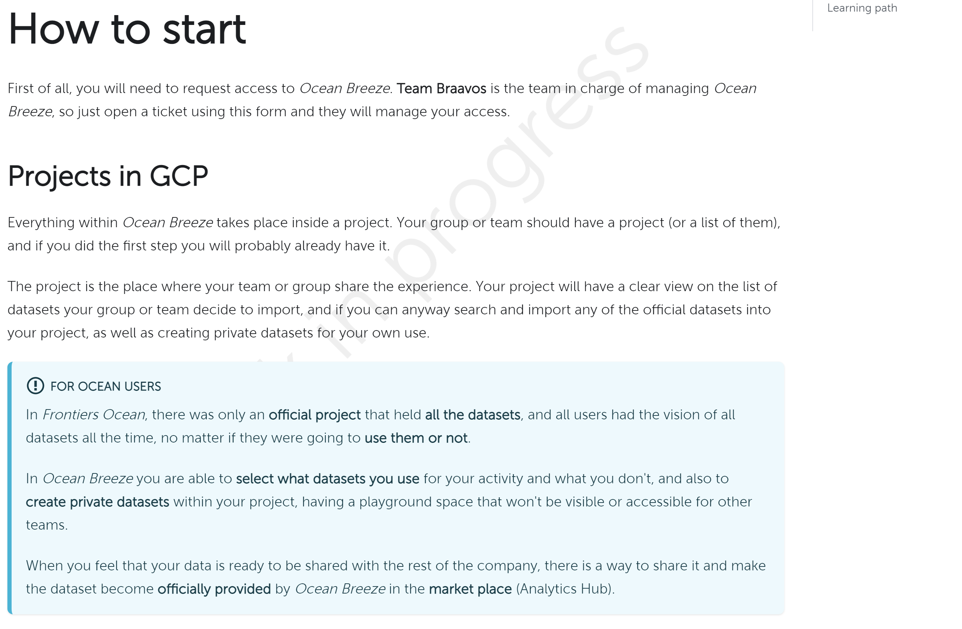

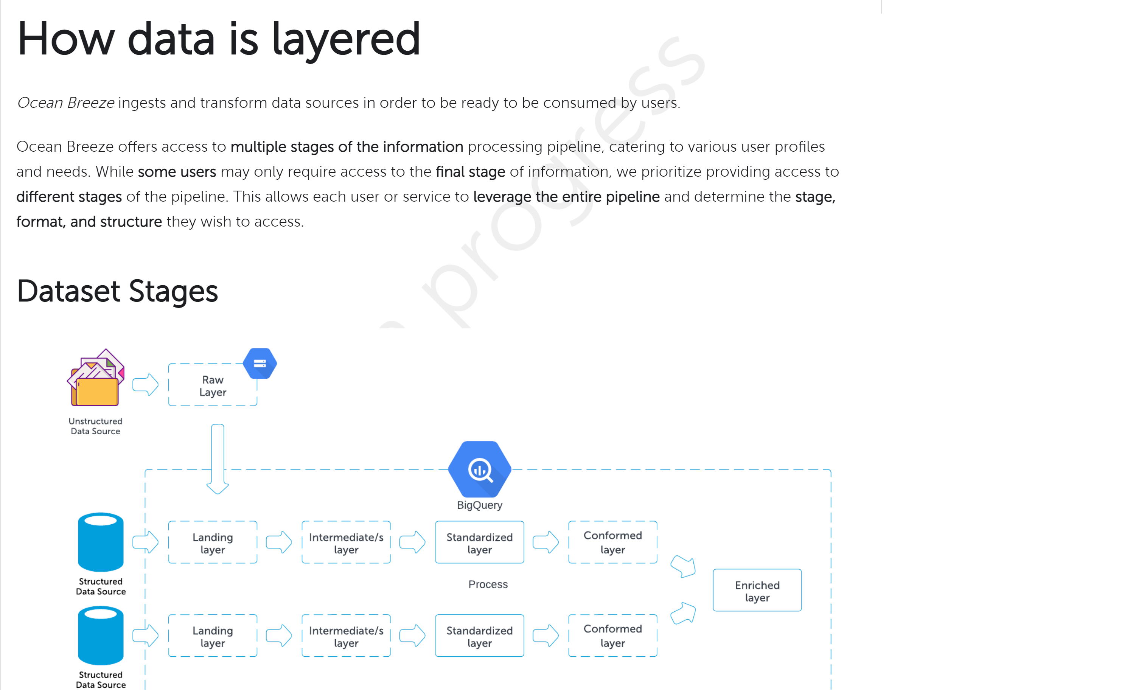

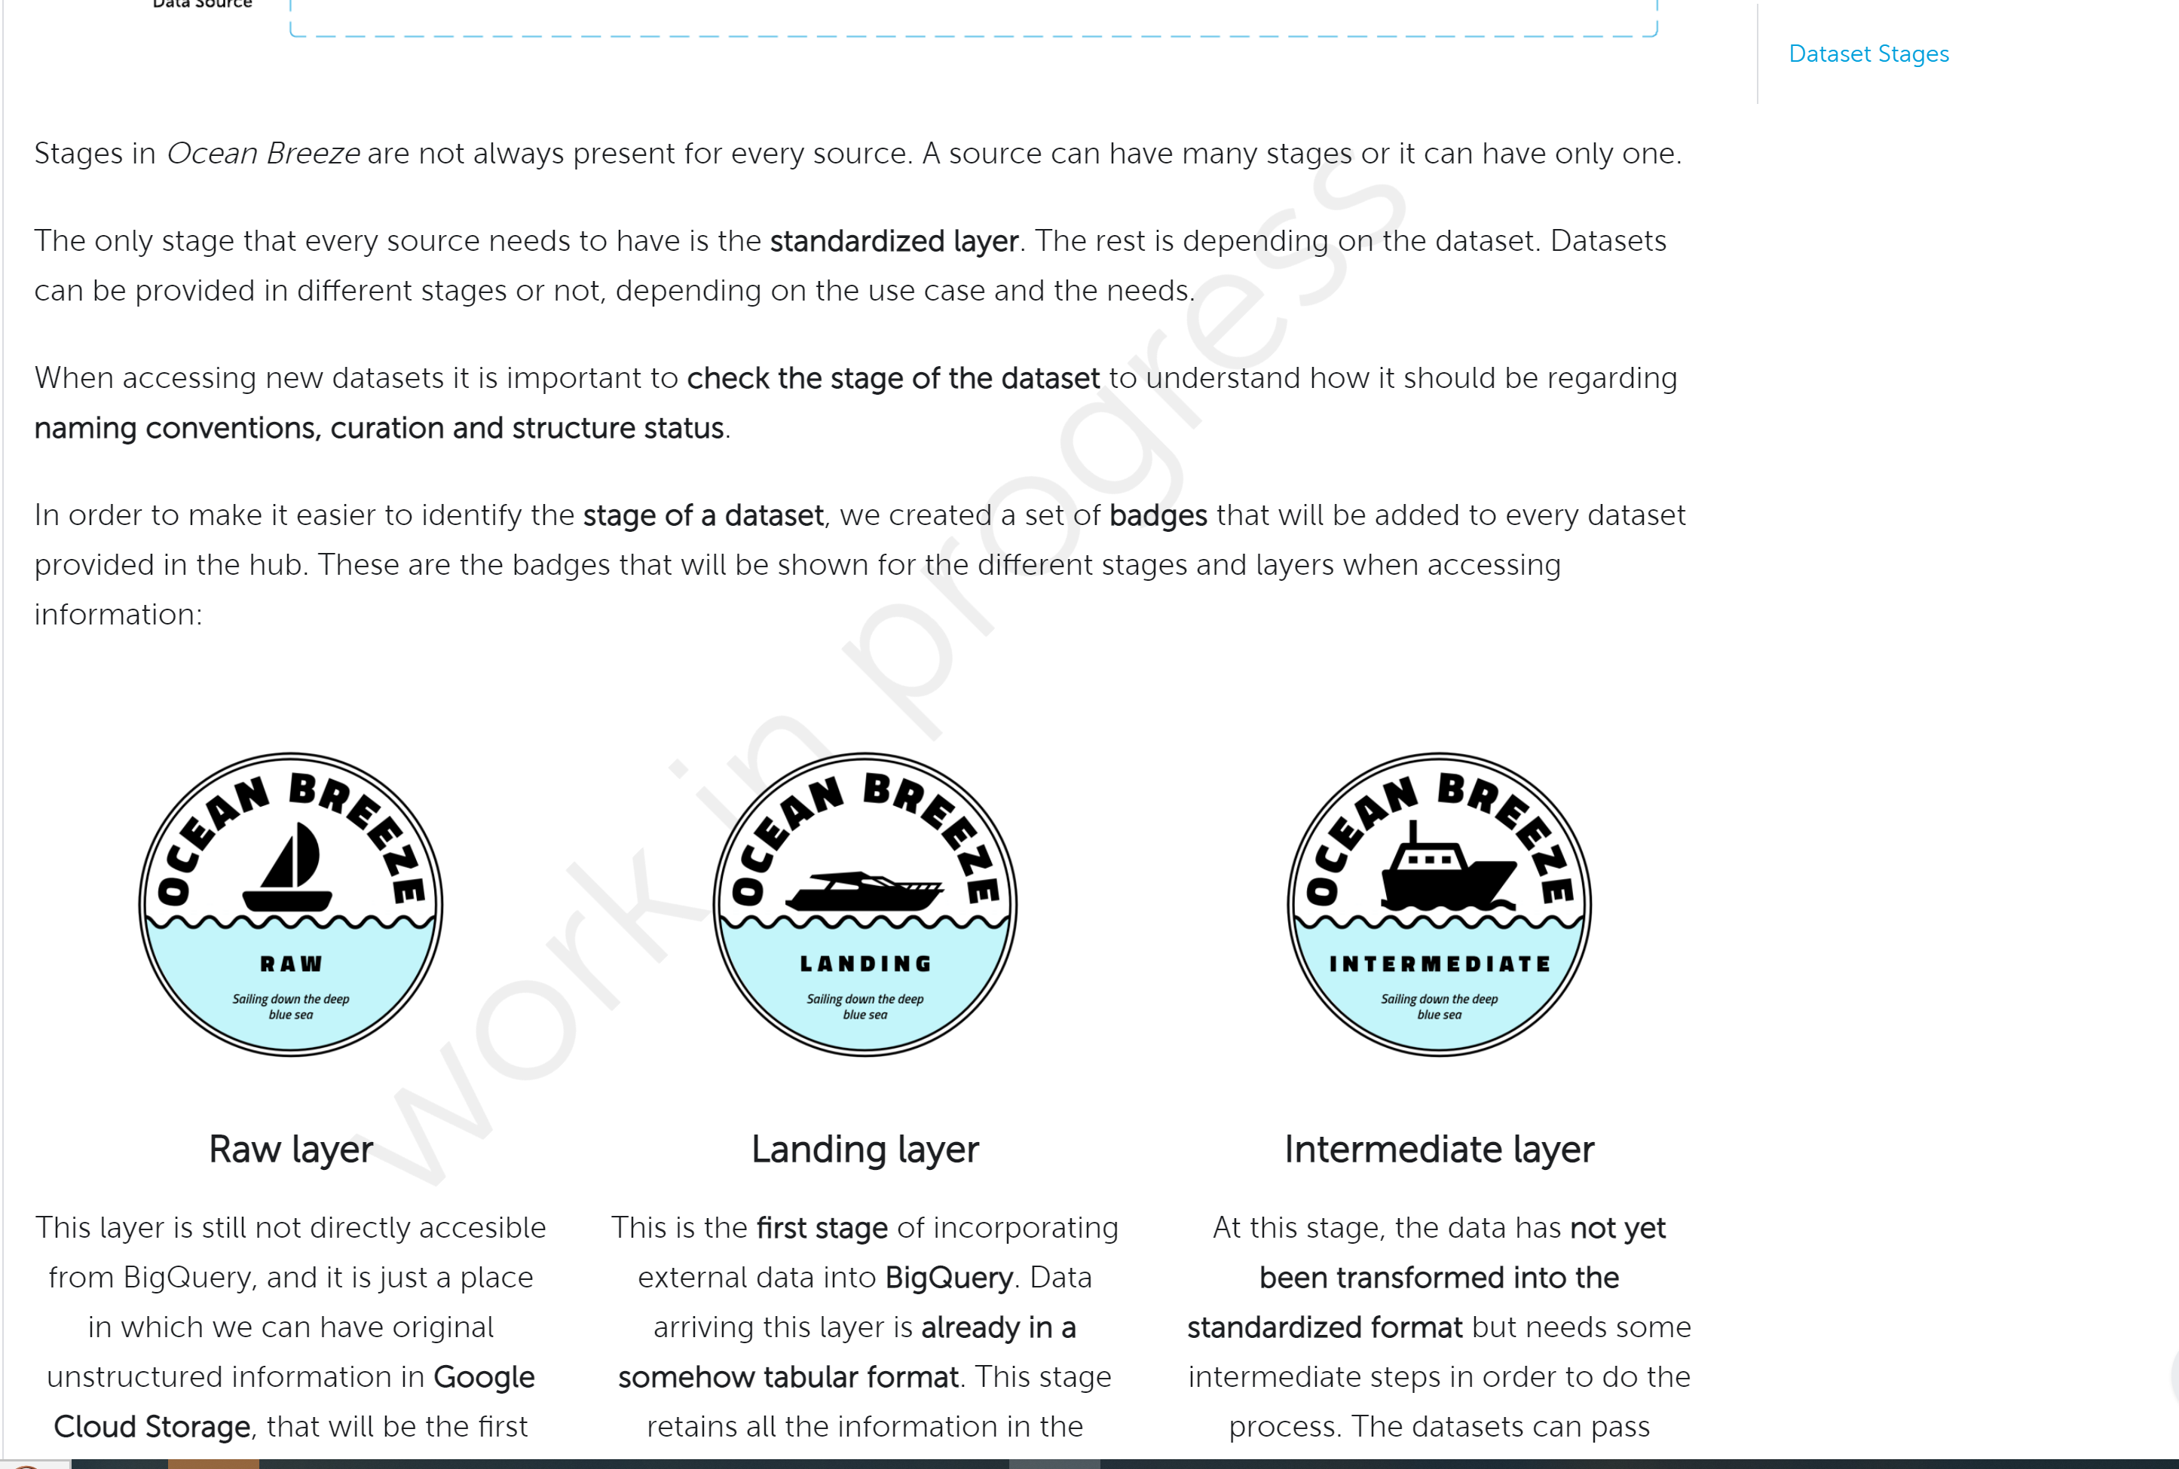

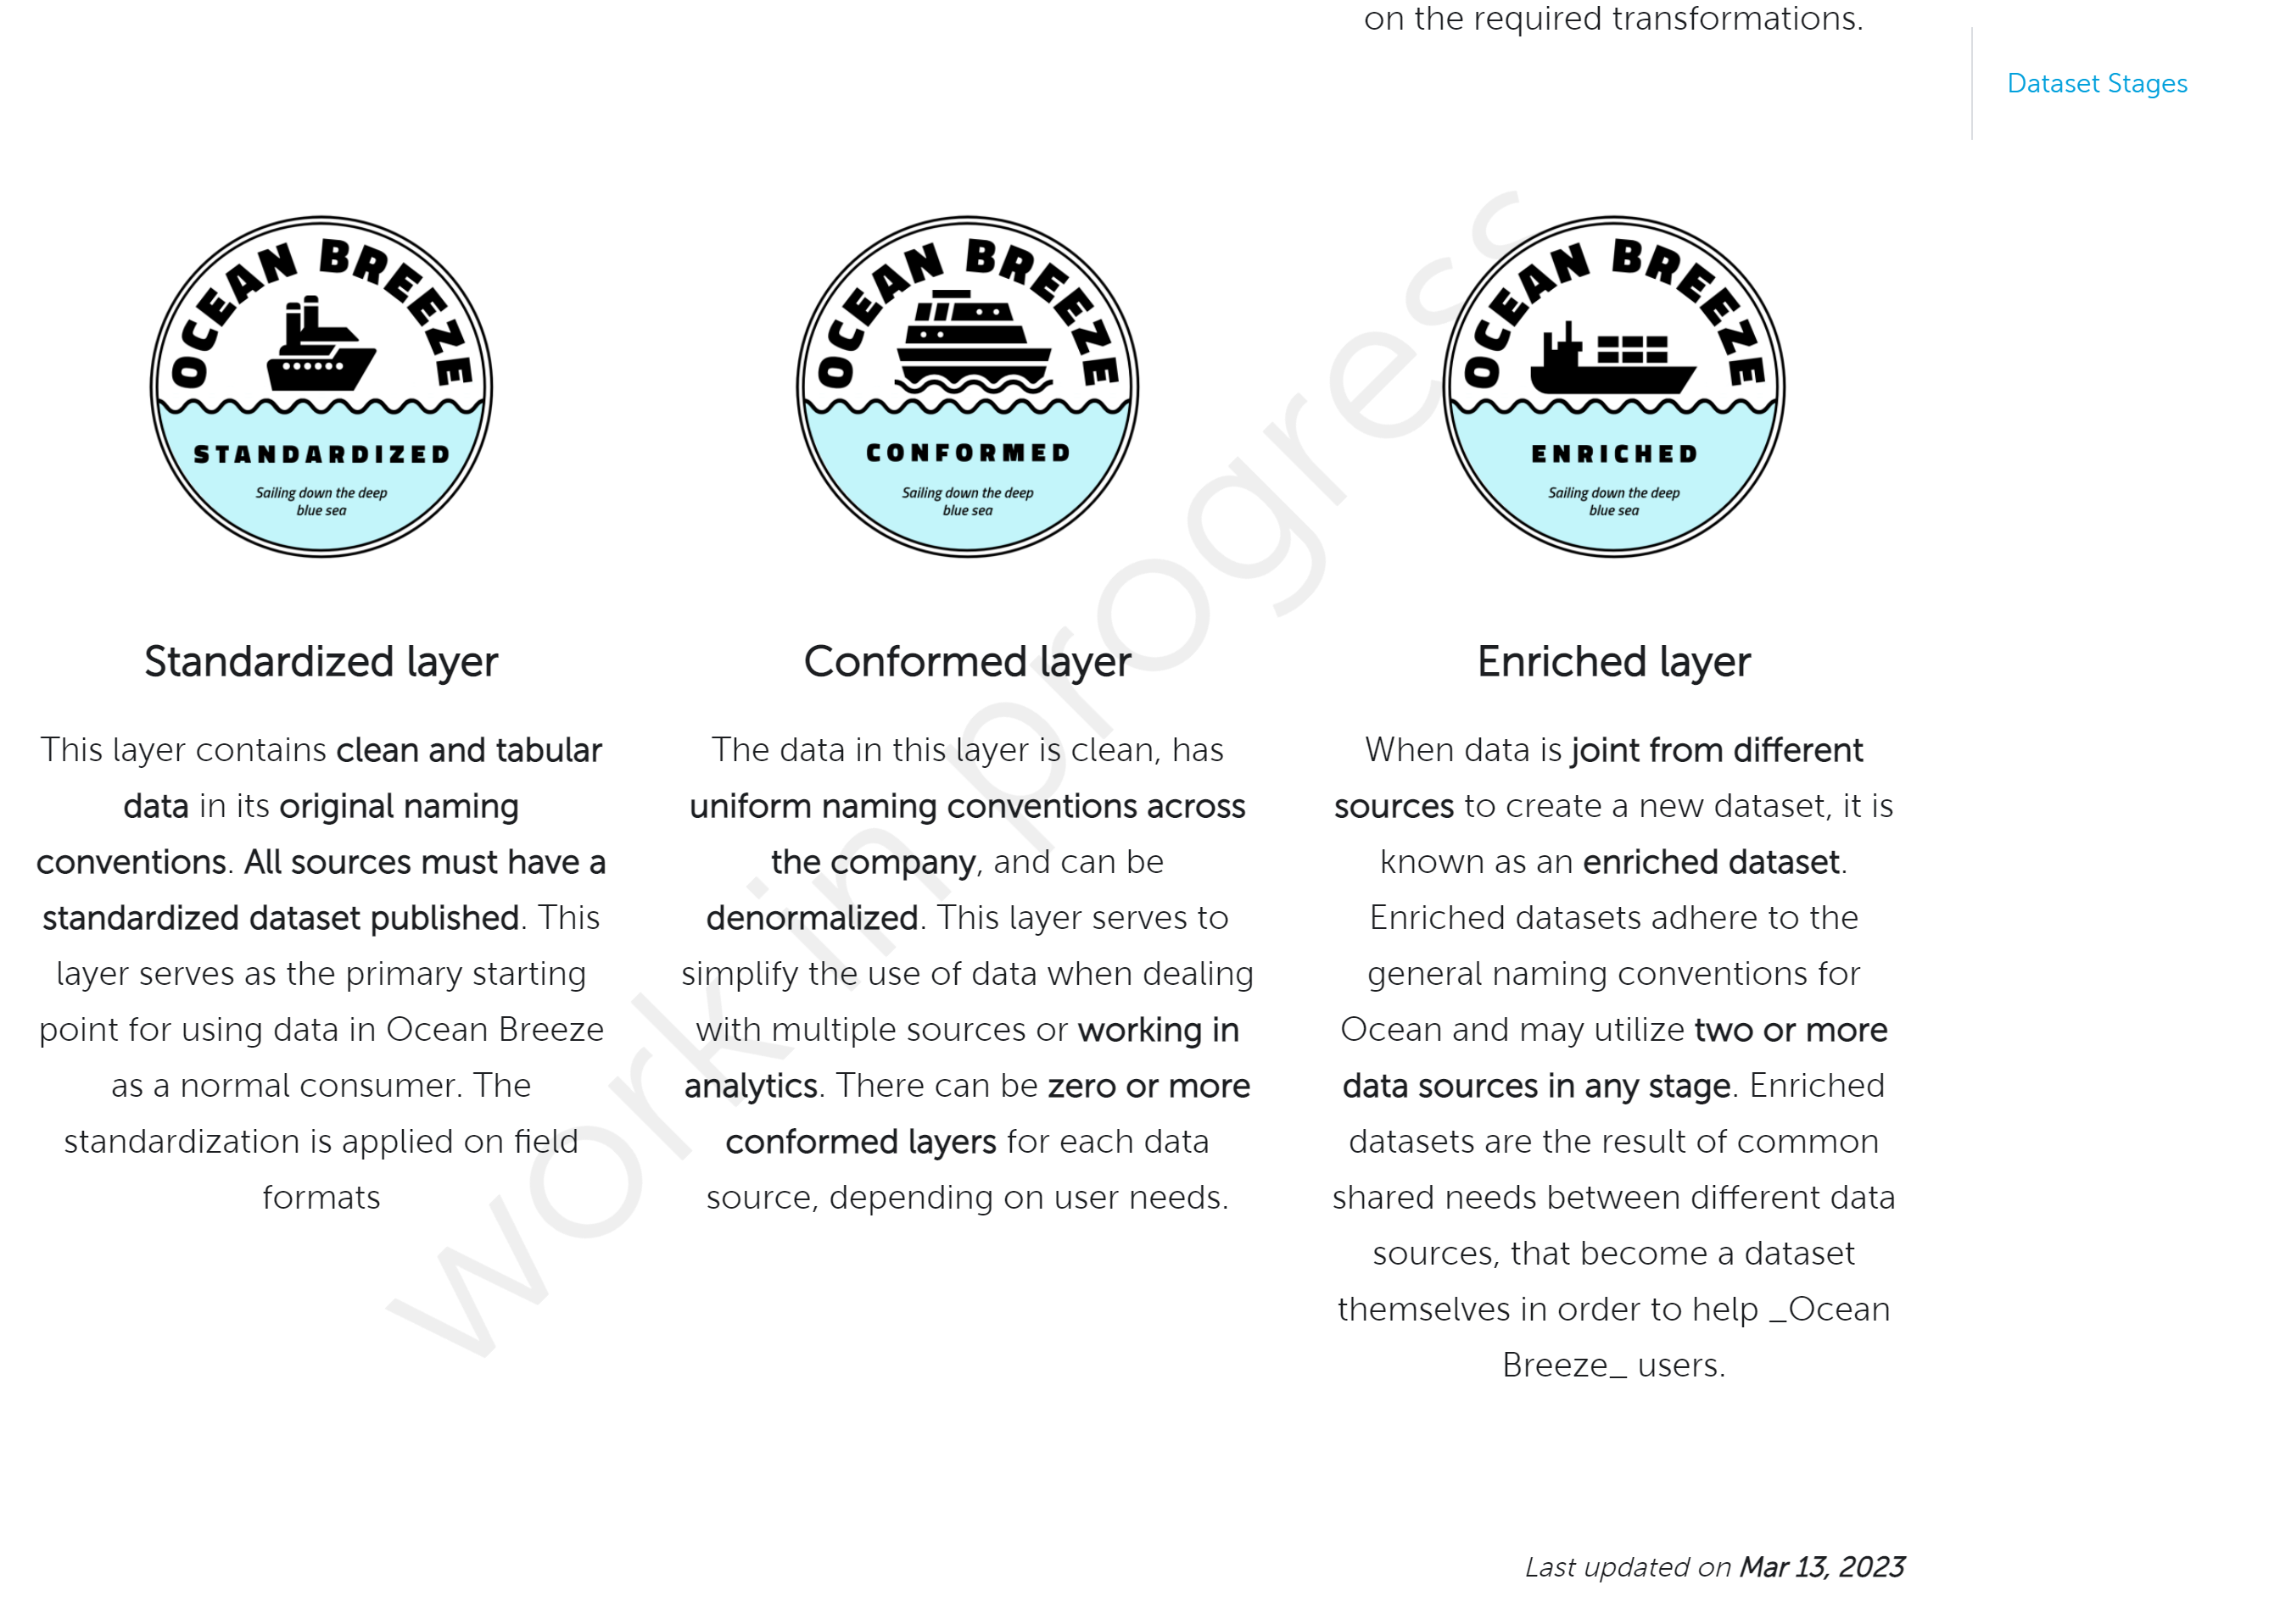

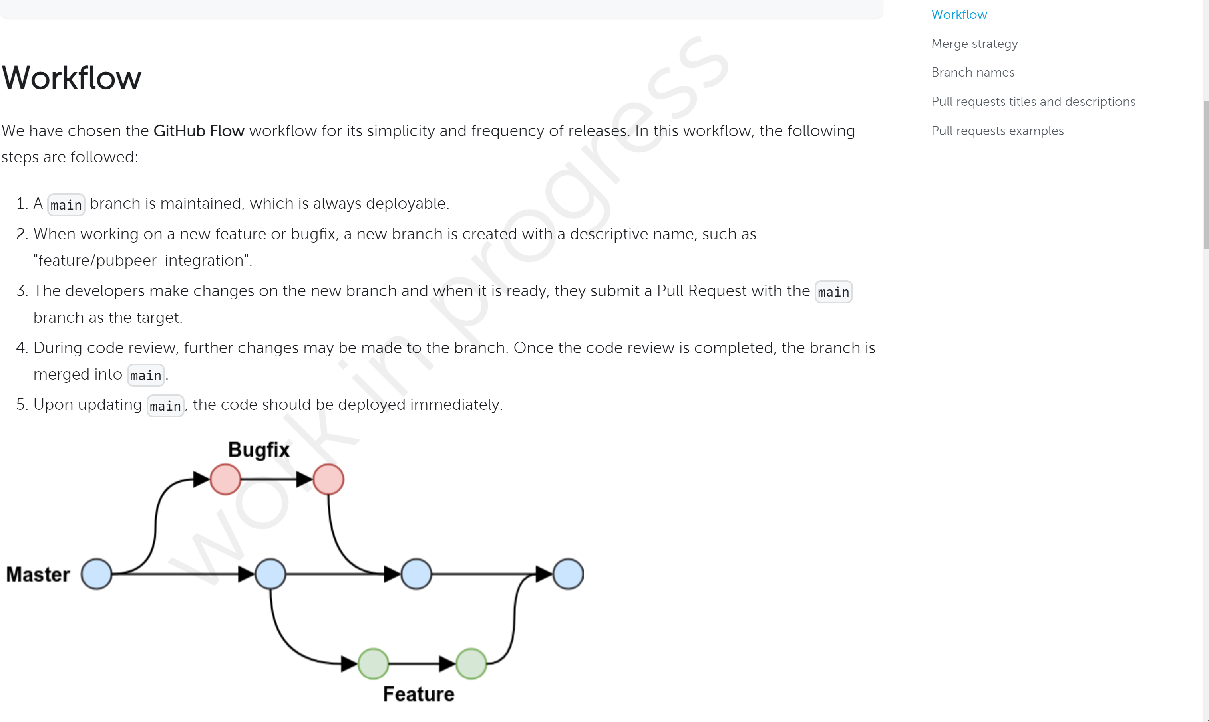

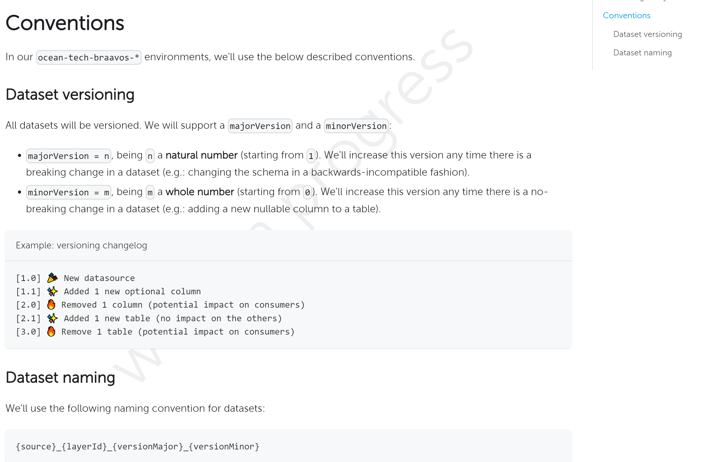



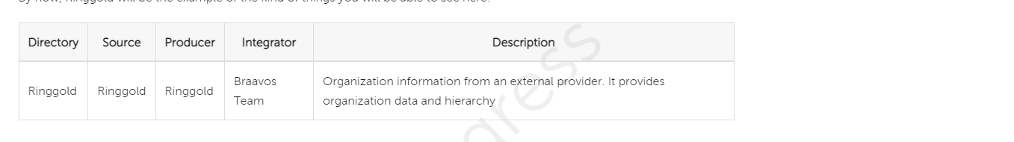

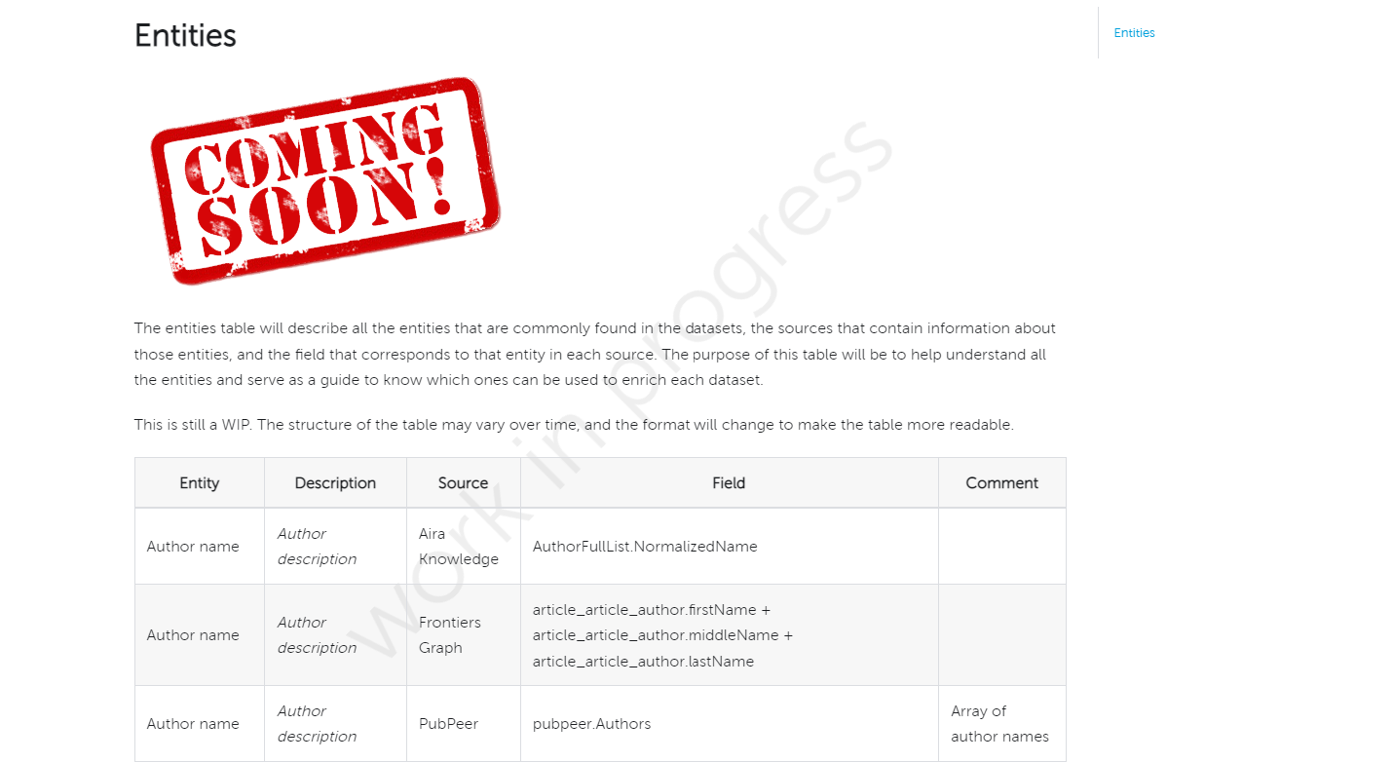

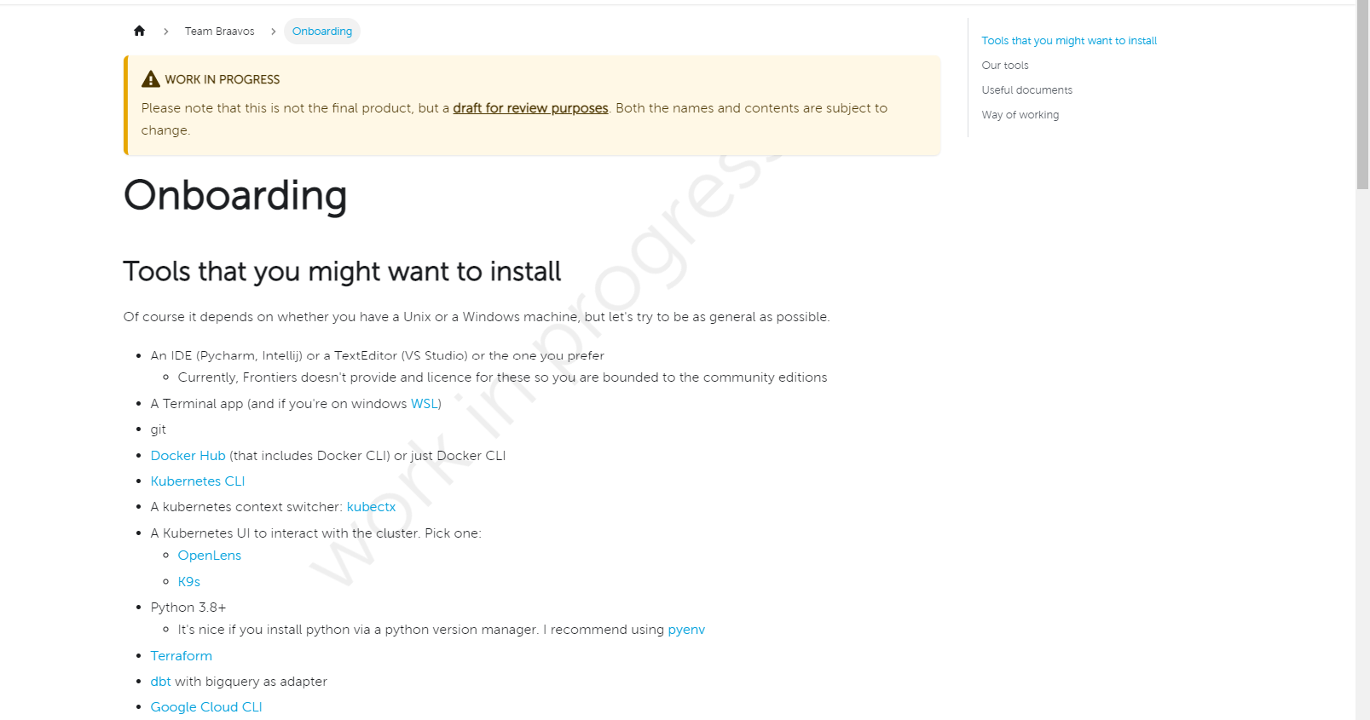

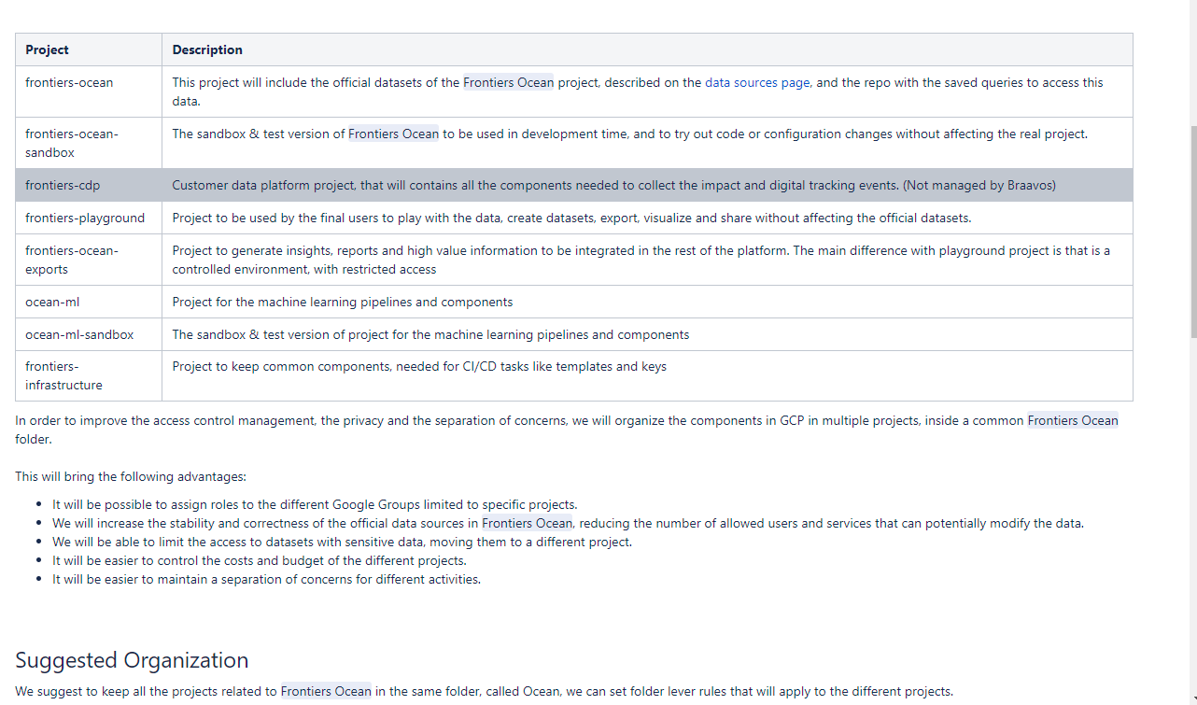

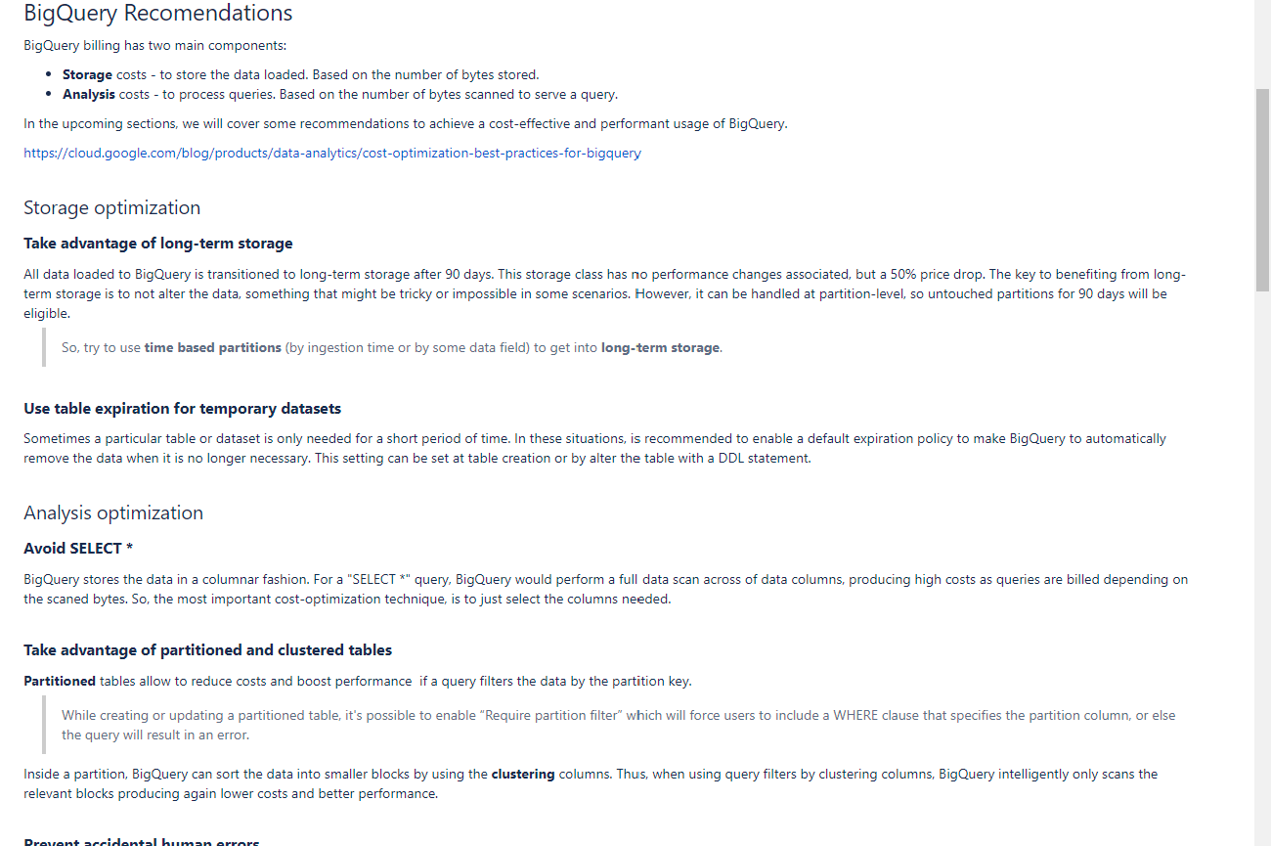

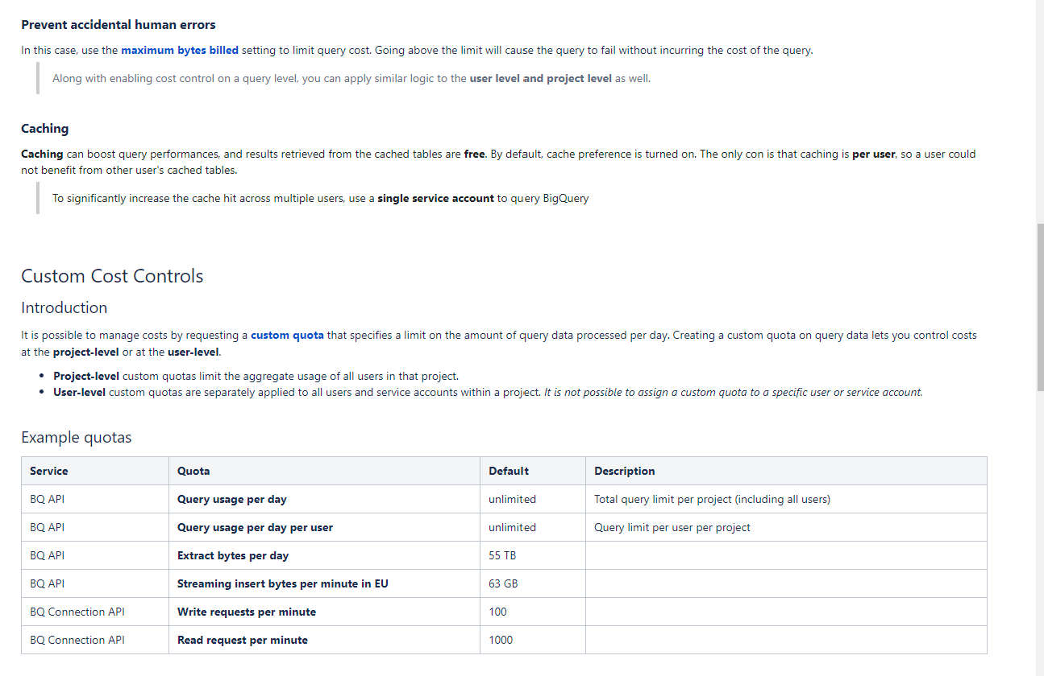

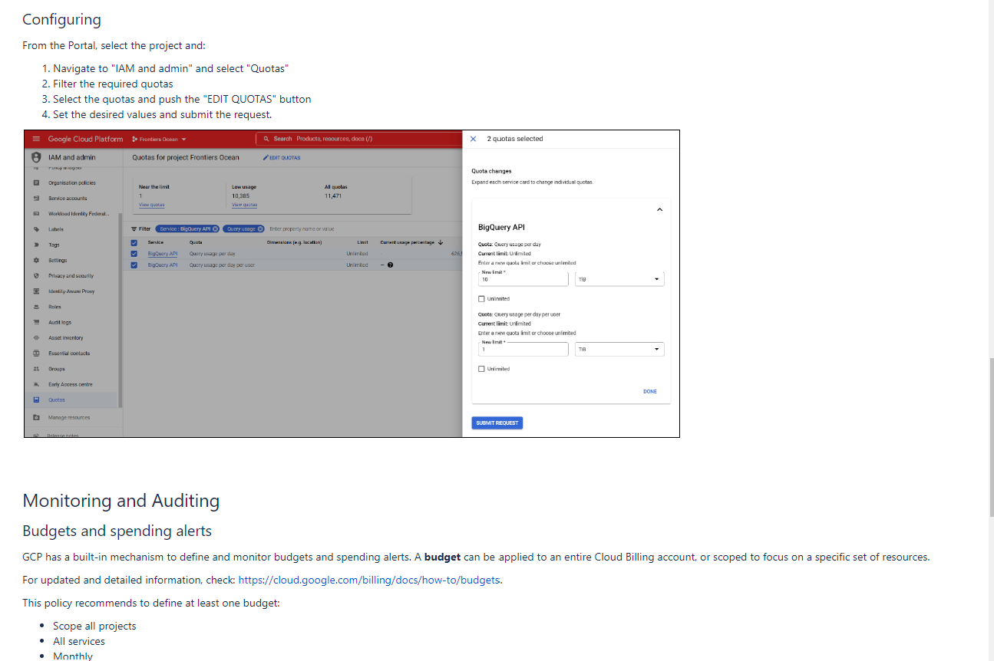

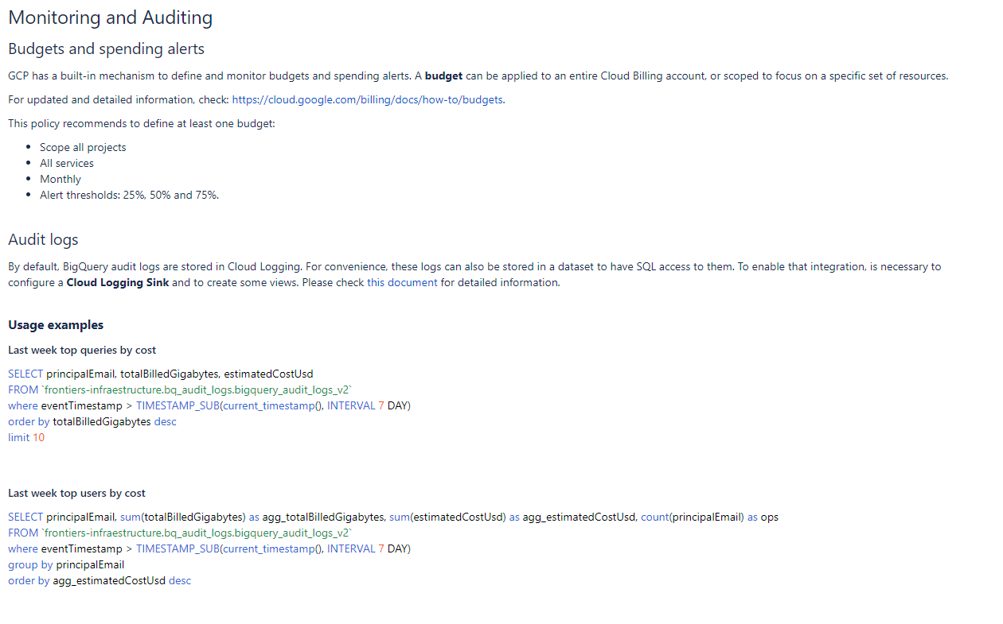

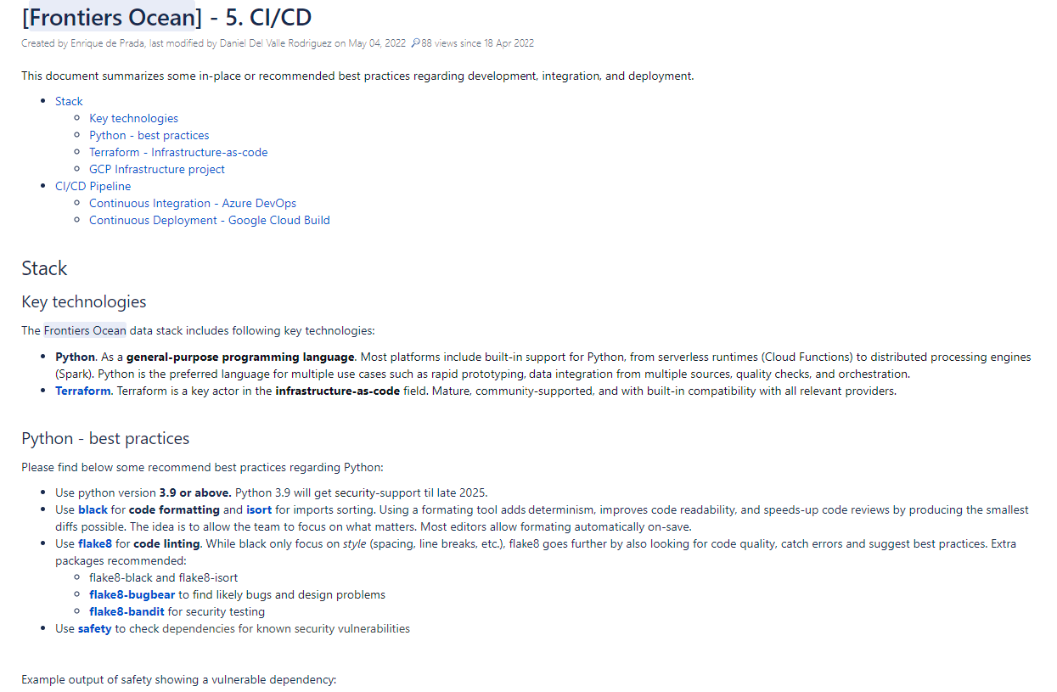

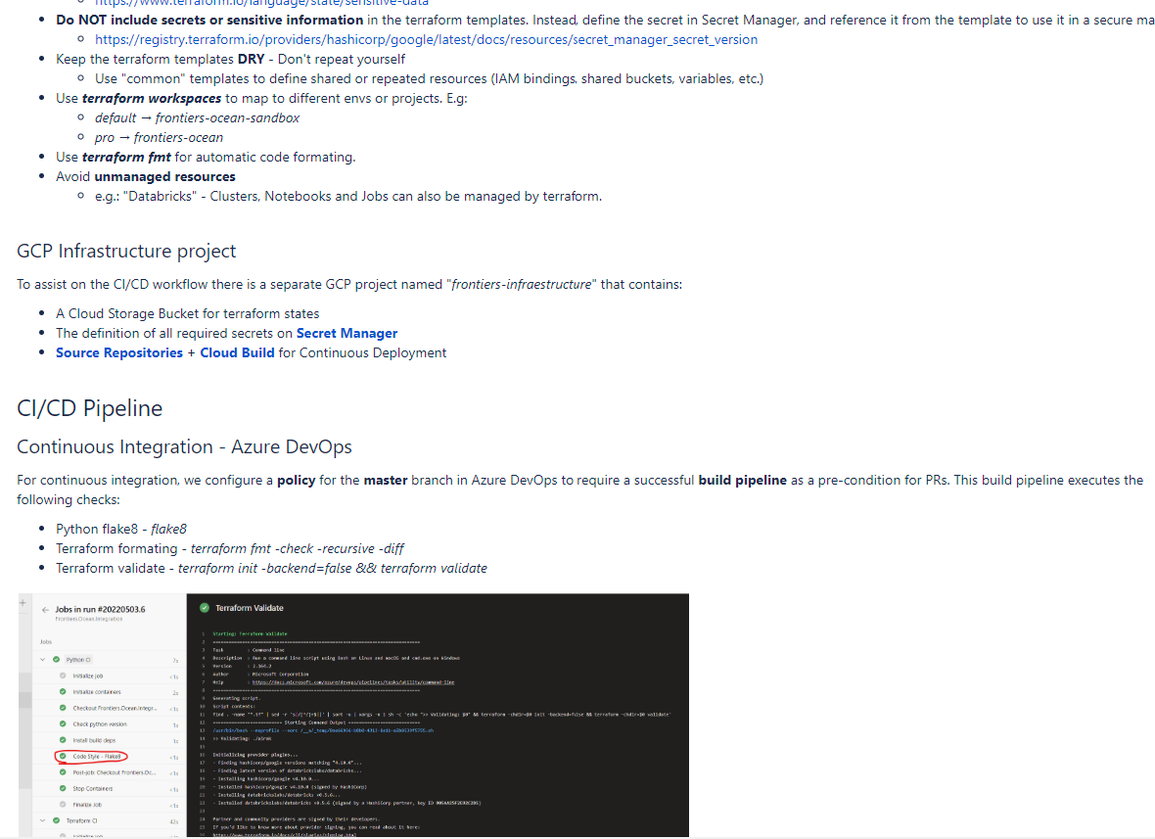

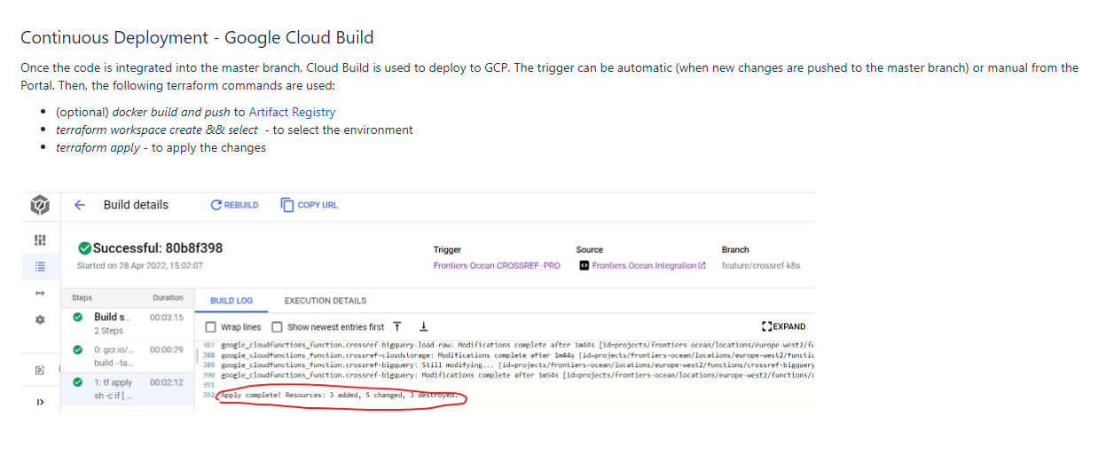

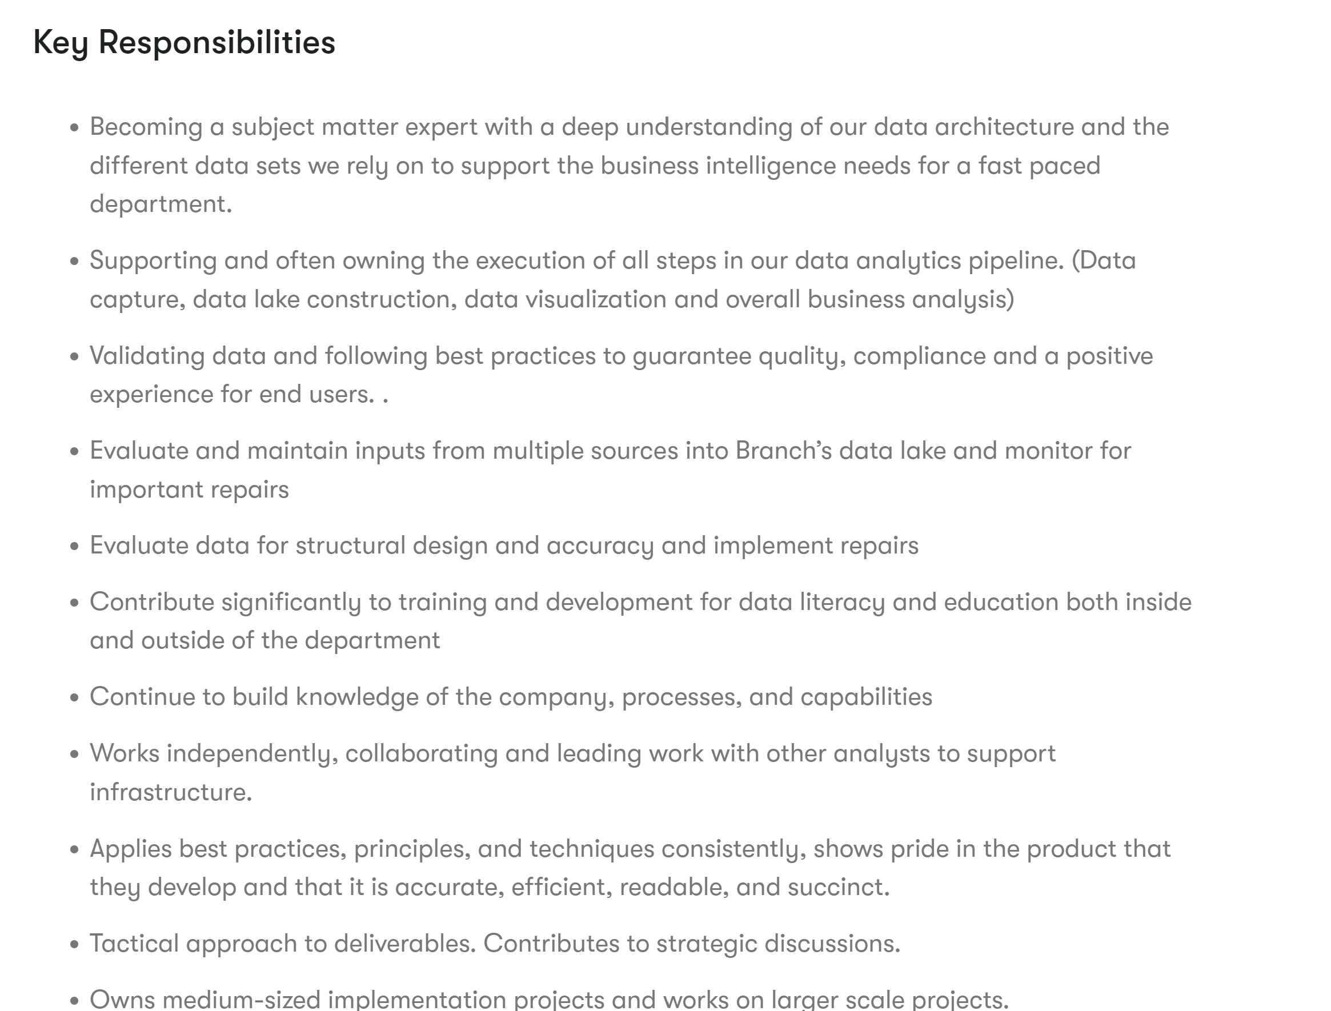

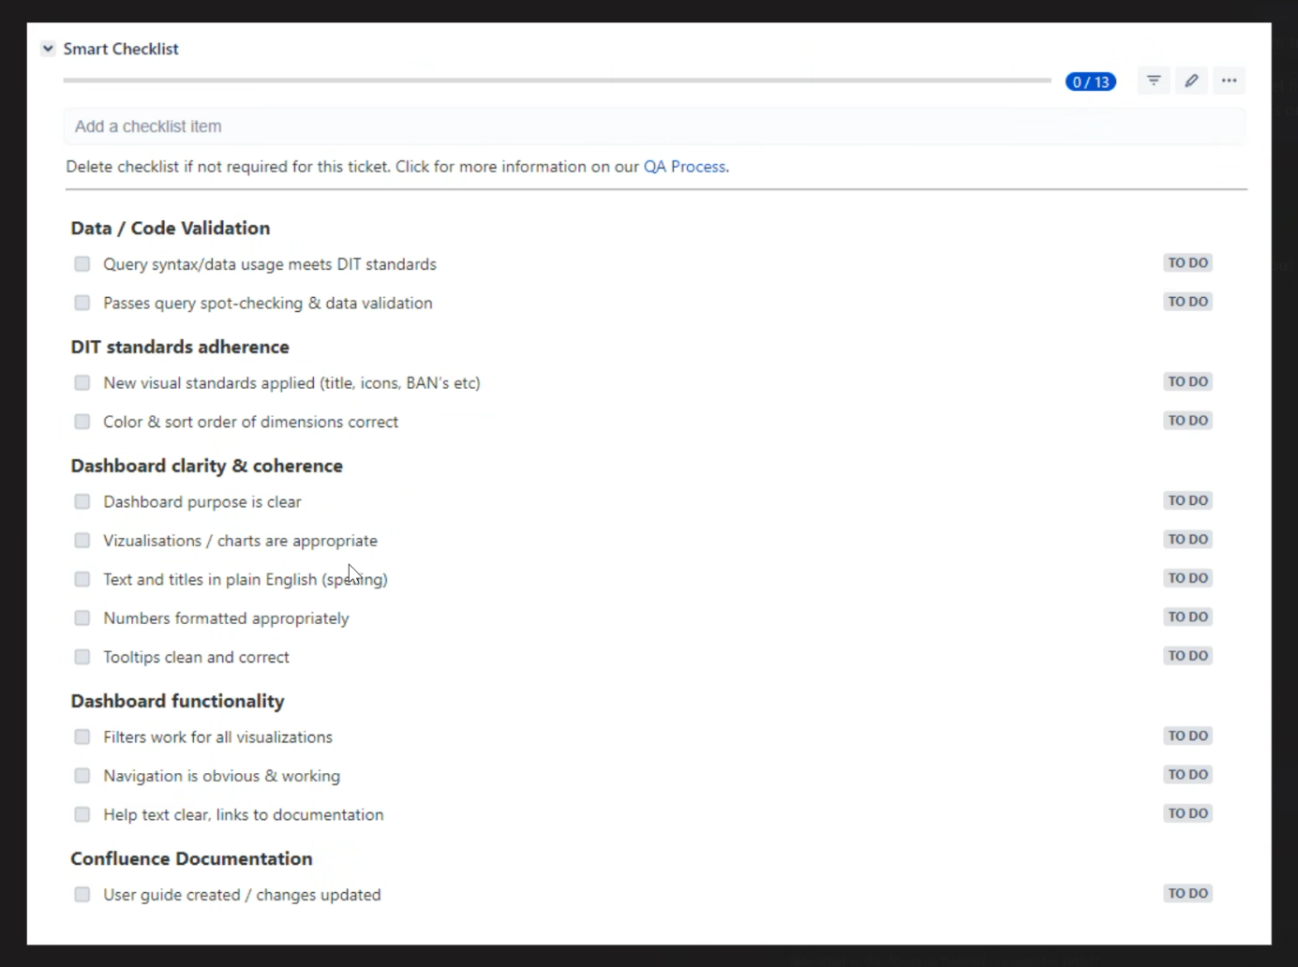

DIT Notification - <Short description> - <Affected start date>

**What is happening?**

<Details of the incident / planned outage including timescale and environment.>

**How will this affect me?**

<For instance - This will affect all / some reports/fields between the hours of x and y on date. You will not be able to use Tableau during these hours.>

**Next Steps?**

<We will advise when the outage / issue is resolved.>

If you have any further questions please comment below.

We appreciate your patience whilst we <resolve this issue / undertake critical maintenance>

**DI Team - <posted date>**

Tableau Scaling Issues

If you are having any issues with Tableau desktop display (more likely with additional monitors, large or high resolution screens) you may see some of the text overlapping or running off the page, then it's likely you need to adjust your DPI settings.

To do this follow these instructions:

1. Click on the Tableau icon (either on your desktop or the folder location) and select 'Properties'
2. In the menu select the 'Compatibility' tab, then 'Change high DPI settings'
3. Select the check box under 'High DPI scaling override', then select 'System' in the drop down.
4. Select 'OK' and 'Apply'
5. Restart Tableau to apply changes.

